**Test Manager**

Use Test Manager to set up tests that can be performed by your laboratory. Configure who tests on what equipment, standard operating procedure (SOP), testing materials, and other significant test parameters.

PREREQUISITES FOR CONFIGURING A TEST

* A Method
* A Test Plan Group and Test Plan for association, if different from the default Clinical and Human
* A Spec Schema, if different from the default NUMERIC_NA and CHAR_NA.
* A Site, Service Group, and Members for performing the test.

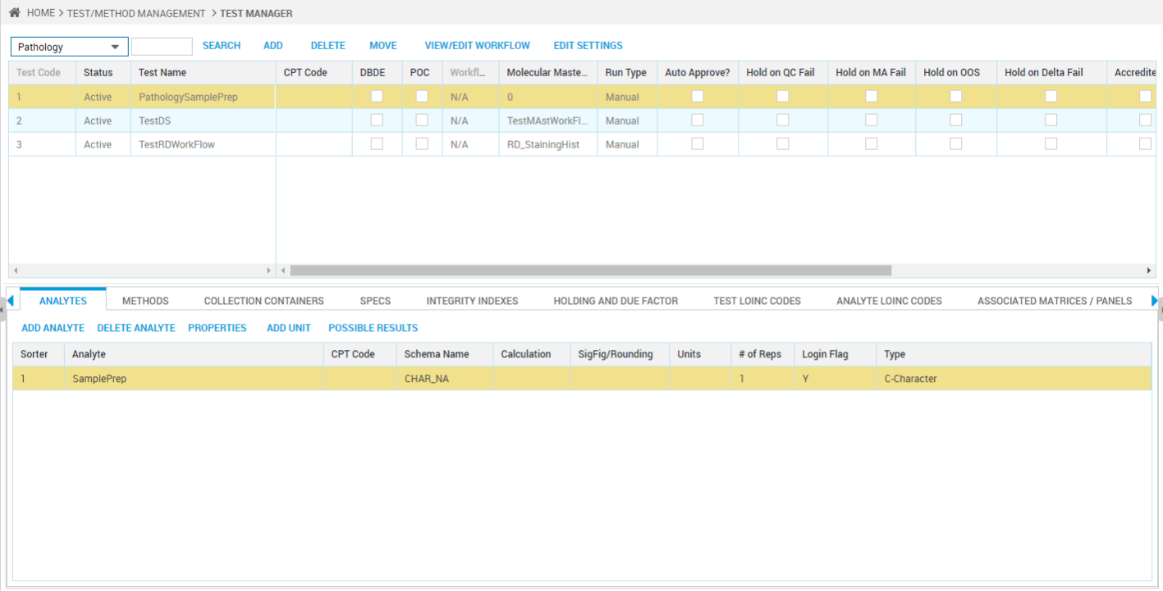

**Test Panels**

Use for defining a test or a collection of tests called a test panel which can be ordered for testing samples during the sample login process.

Prerequisites:

* Test Plan, if other than Human.
* Tests.
* CPT Codes in the CPT Codes/Medical Necessity application, if any.
* ICD Codes to be linked to CPT Codes for a disease.

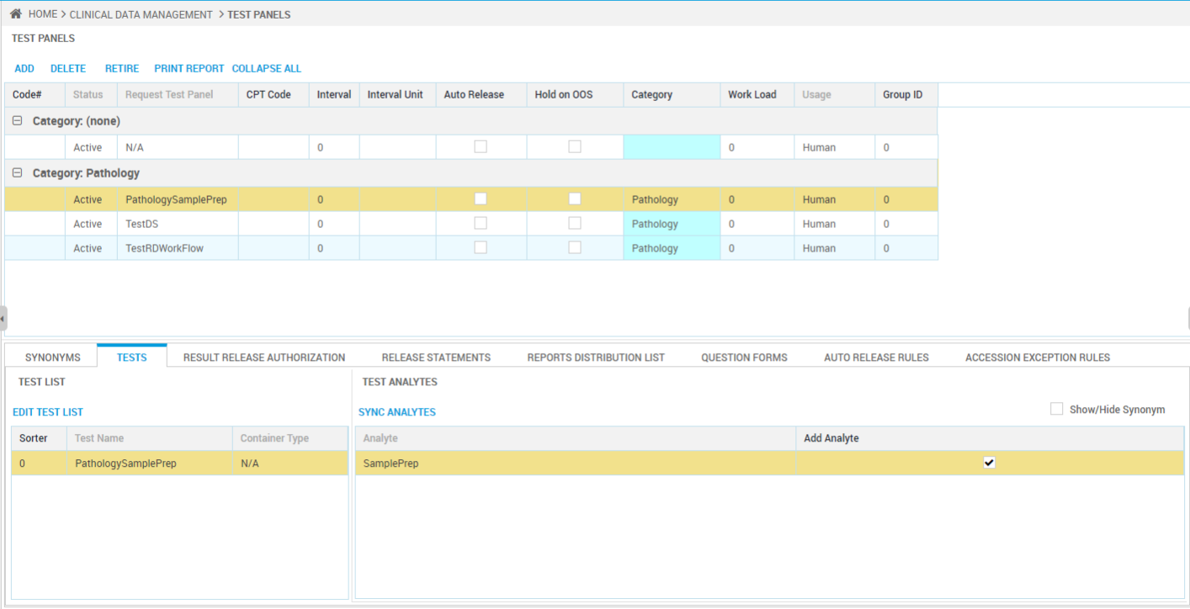

**Material Manager**

Use to maintain records of materials in your laboratory and include safety information, chemical/physical properties, labels, recipes, concentrations, and so on.

Open Materials Management > Material Manager.

TOOLS FOR LOCATING EXISTING MATERIALS

Search tools include:

* Select - Click to open a box and search by:
* Material Type - Category, such as Reagents, used to group similar materials.
* Material Name / Material Synonym - Names known to personnel.
* Material Code - Unique code used by the system to locate the material.
* Inventory ID - Use this identifier which typically appears on an inventory item label.
* Search for: [Go] - Type first characters of a material code in this box and click Go to find the first match.

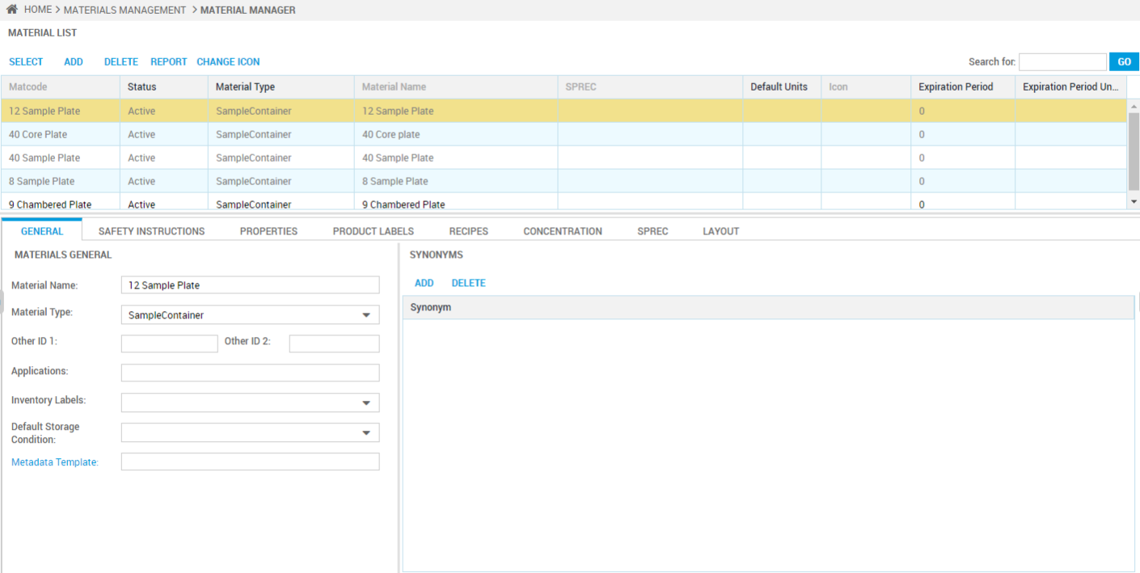

**Trial Manager**

Use to define a clinical trial visit schedule for subject participants and assist in building collection kits. Testing can be according to population segments, such as infants, females between the ages of 18 and 45, people over 65 who have had chicken pox, laboratory animals, and so on.

PREREQUISITES

* Create, Review, and Release Buttons - Required buttons in General Workflow Manager using the Trial Manager Workflow in Description with CTWF in Application Reference.
* Important If the CTWF workflow does not exist, create it as follows: 1. Create step with Logged status, 2. Review step with Reviewed status, and 3. Release step with Released status.
* Metadata Templates:
* By default, the Details/Milestones tab uses the TRIAL_MANAGER template and Trial Sample Login uses TRIAL_LOGIN. Do not delete them from the N/A group.
* To create alternative Metadata Templates for specific trials according to facility:
* Configure a Study usage template to replace TRIAL_MANAGER. In a trial, use the Set Metadata button to select from Study templates.
* Configure a Patient usage template to replace TRIAL_LOGIN. In a trial, use the Set Subject Metadata button to select from Patient templates.
* Trial Types - Configure selection for the Trial Type drop-down box using the Clinical Trial Types Lookups list.
* Tests and Panels - Configure the trial tests in Test Manager and include them in panels in Test Panels. These display for selection in the Test Panels tab.

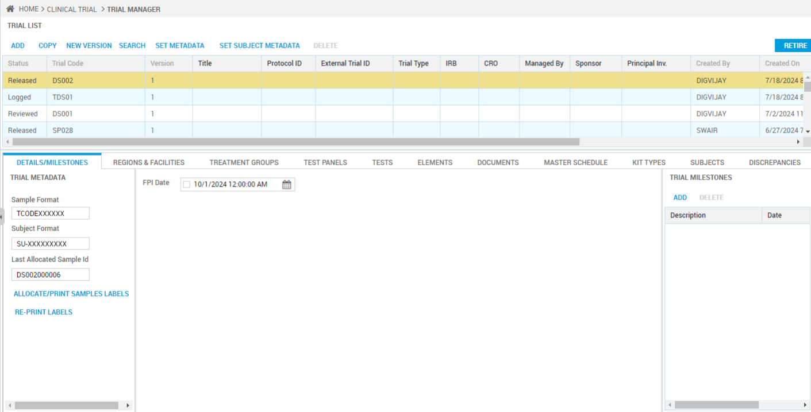

**Workflow Configurations :**

**Workflow Engine**

Use to configure workflows that require multiple steps to support complex treatment and testing. Each step typically has its own inputs, outputs, equipment, materials, transactions, routing, and so on.

When creating a workflow, consider that some steps, such as DNA Extraction and Quantification, may be useful in more than one master workflow. To save effort, include reusable sequential steps in a common workflow to add to more than one master workflow. A master workflow can contain both shared and unique workflows.

Prerequisites for creating workflows and workflow steps:

* Workflow Items - Steps need input and output sample types, container types, and/or plate template combinations. Configure Workflow Items.
* Workflow Actions - Use available transactions at the processing step level.
* Materials - Needed step materials such as Reagents and Adapter Indexes must be configured in Material Manager.
* Equipment - Testing equipment must be configured in Equipment Manager.
* Quality Controls - Controls to be used in steps must be in QC Manager.
* Question Forms - Questionnaires, if any, must be in Clinical Data Management > Question Forms.

Adding Workflow

1. Open Workflow Setup > Workflow Engine.
2. In the Workflows pane, click Add and complete a code, name, and description.
3. Alternatively, save time by copying a similar workflow and modifying it. Click Copy Workflow and type new identifiers.
4. If the workflow is configured elsewhere, consider using Import to add it into this LIMS.

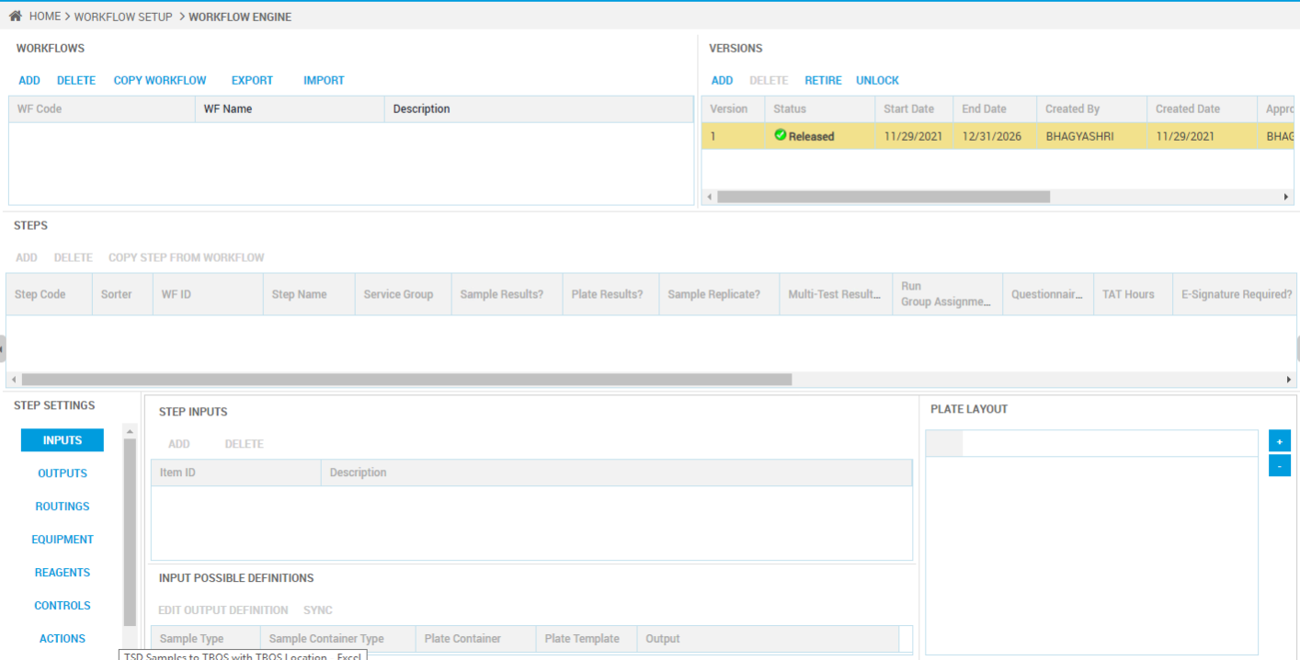

Adding Step To Highlighted Workflow

1. In the Steps pane, you can copy a step:
2. Click Copy Step from Workflow.
3. Mark the check box to list all versions. Otherwise, Released versions are listed.
4. Select the workflow and step.
5. Alternatively, click Add and complete:

* **Step Code** - A short form of the step name.
* **Step Name** - Type a descriptive name so personnel can choose the correct step.
* **Service Group** - Select the team of analysts who can do the processing at the site. About services groups, see Configuring Service Groups within Sites.
* **Sample Results** - Mark if samples will have results entry at this step and are in a container other than a plate, such as a tube.

Sample Results and Sample Replicate cannot be marked at the same time because you use the Results step to configure one or the other.

* **Plate Results** - Mark if samples in a plate will have results entry at this step.
* **Sample Replicate** - Mark to provide results entry for sample replicate wells. When personnel move a sample to a plate well using the Plates Tab during Workflow Processing, the related replicate wells are populated. Personnel can later type a result in each well using the Sample Results Tab.
* Prerequisite: A plate template containing replicates for samples must be associated with the processing step where replicates are added.
* **Multi-Test Results** - When multiple tests are assigned to the specimen, mark to create a result record for each. If clear, one test code is selected for results entry.
* **Run Group Assignment** - When marked, if the user assigns a sample or control that belongs to a wells group in a plate template configuration, then the system assigns all samples or controls within that wells group to the run. This can prevent the user from forgetting to assign some grouped samples/controls to a run for a workflow step. Clear the box to allow a user to move samples/controls to a run without considering inclusion in a wells group.
* A user can define one or more wells groups in a plate template using the Set Wells Group feature. See Plate Configurations.
* **Questionnaire** - Mark if you want an attached questionnaire completed at this step.
* **Turnaround Time (Hrs**) - Provide the time by which this step must be completed and routed to the next step. TAT Hours in the grid displays the number. (This is informational only.)
* **E-Signature Required** - Mark to require lab personnel to provide an eSignature before the step can be Finished. (The system comes with three eSignatures. If you add more, use the MOL_ prefix, see Electronic Signatures Tab.)
* **Electronic Signature** - Select a signature from the drop-down box. Only eSignatures with the MOL_ prefix are displayed.

1. Click in other fields and complete:

* **Sorter** - Sort order for included steps.
* **Peer Review Required** - Require that someone else in the service group approve the completed information.
* By default, the system marks this check box. It is recommended that you keep Peer Review enabled for results steps to help ensure accuracy. Disabling the check box removes this safety mechanism.
* **Information Form** - Select from forms in the Designer under Molecular > MolecularInformationForms in Applications. You must be a power-user to make forms available.

1. Next, find Step Settings and configure each setting.

**Workflow Action**

Work with both system and custom actions to use in the Workflow Engine. Actions, or transactions, will display for selection in the Workflow Processing application menus. Personnel use actions such as Auto Map Samples to Plate to perform tasks such as moving current Sample #s into plate wells.

System actions come with the system and cannot be deleted but you can configure some elements.

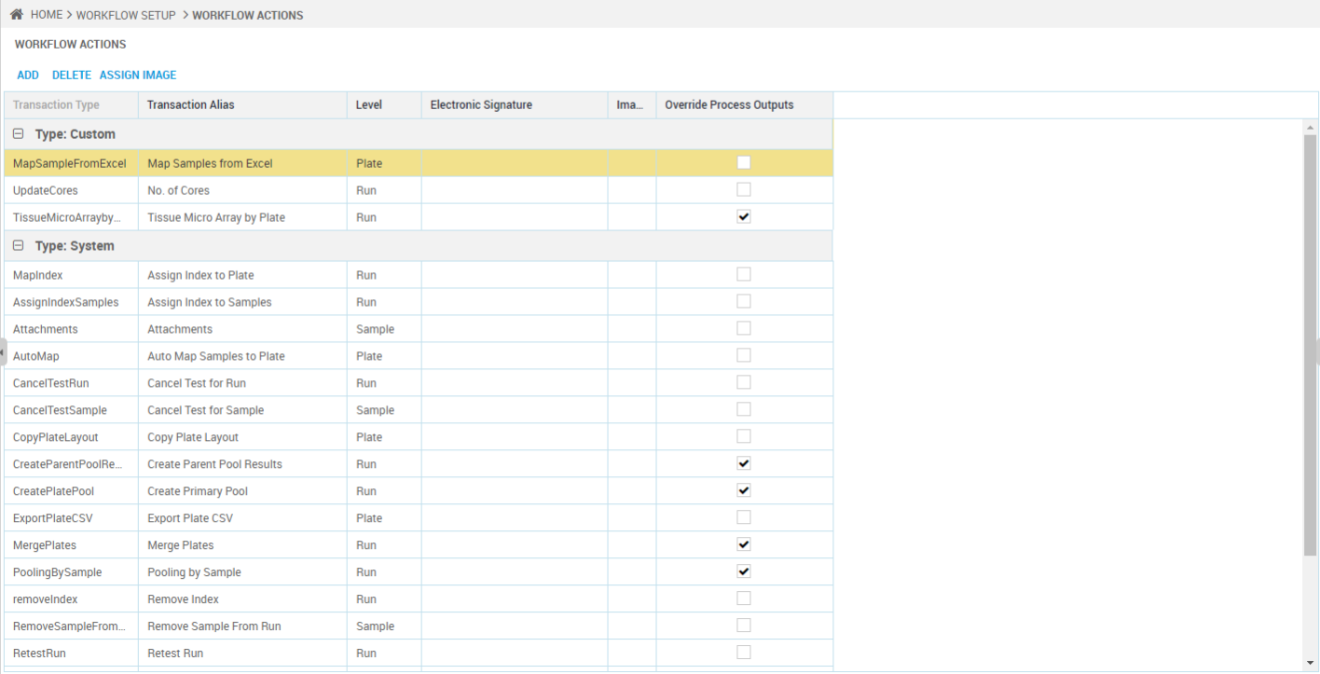

**Configuring an Existing Action**

1. Open Workflow Setup > Workflow Actions. Existing Custom and System actions are listed.
2. Select a cell in the grid to complete:

* **Electronic Signature** - Select from electronic signatures configured with an MOL_ prefix in Utilities > Settings > Electronic Signatures Tab. When personnel select the action in Workflow Processing, the signature dialog box displays as configured in the Electronic Signatures tab.
* Choosing a signature selects the signature dialog box that appears when the action is performed.
* **Image** - Use an image to help personnel locate this action in a menu. Double-click in a cell or click the Assign Image button. See Image Picker for details.
* **Override Process Outputs** - When marked, the executed action must handle the Processing Step's outputs. Make sure the action is coded accordingly. Accept the base system setting for System actions.

1. You can click in the grid to update other editable cells as needed. You cannot edit Transaction Types. AutoMap, in the System category, is an example of a Transaction Type. Transaction Types are used by the system to identify a function with the same name.

**Adding Custom Action**

1. To add a Custom action, click Add.

A custom action requires underlying code. That is, someone must add a function and scripts in the Designer under Molecular.MolecularActionProcessing. Otherwise clicking the action in Workflow Processing will not do anything.

1. Complete:

* **Transaction Type** - Type the name of the function that will execute the action.
* **Transaction Alias** - Add a description to help personnel select the action, such as Import Nanodrop Results.
* **Action Level** - Select whether the action will display in the Run, Sample, Plate or Pending menu in the Workflow Processing application.

1. Continue configuration following the prior procedure, Configuring any Action.

Removing Custom Action

1. To remove a highlighted, unused Custom action, click Delete.